**Screenshot – Assignment 12 by Venneti Kalyana Chakravarthy**

Read the following data set:

<https://archive.ics.uci.edu/ml/machine-learning-databases/adult/>

Rename the columns as per the description from this file:

<https://archive.ics.uci.edu/ml/machine-learning-databases/adult/adult.names>

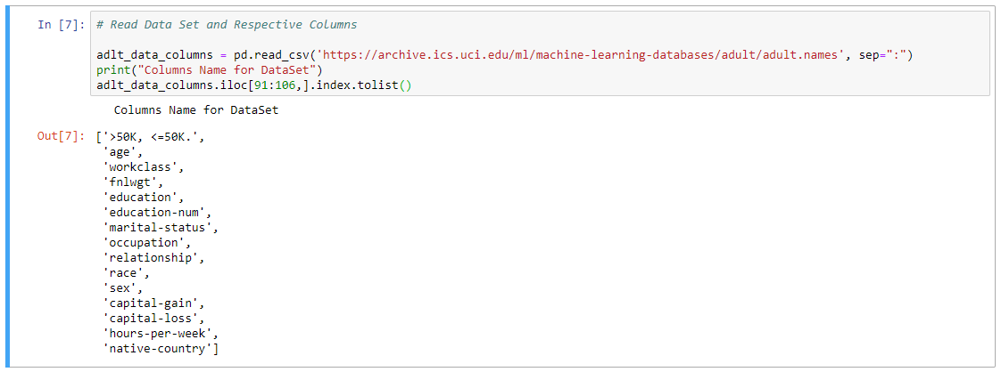

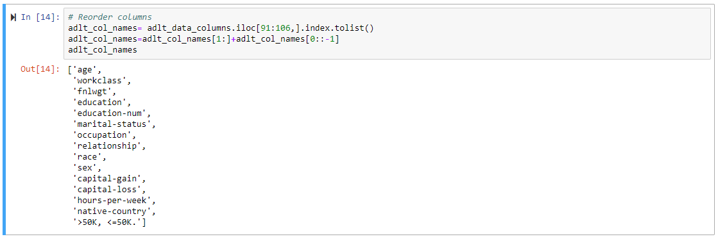

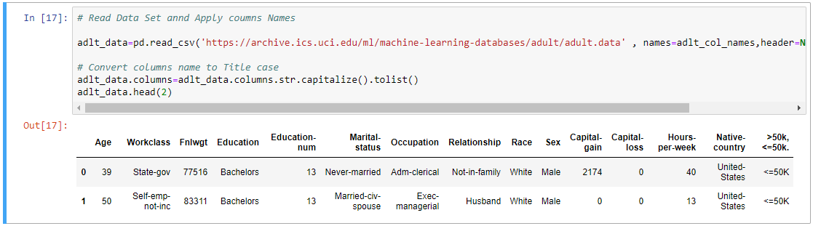

Task:  
Create a sql db from adult dataset and name it sqladb



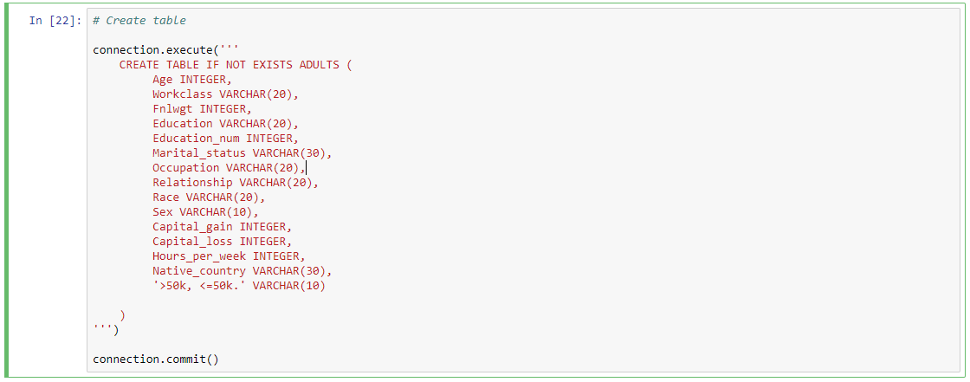

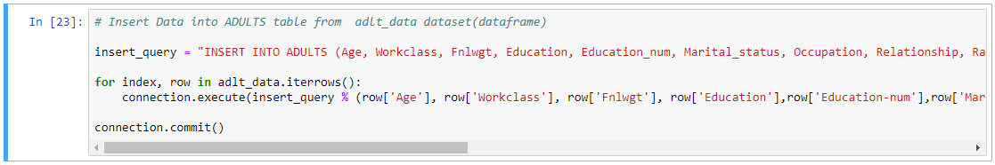

**Question 1:** Select 10 records from the adult sqladb

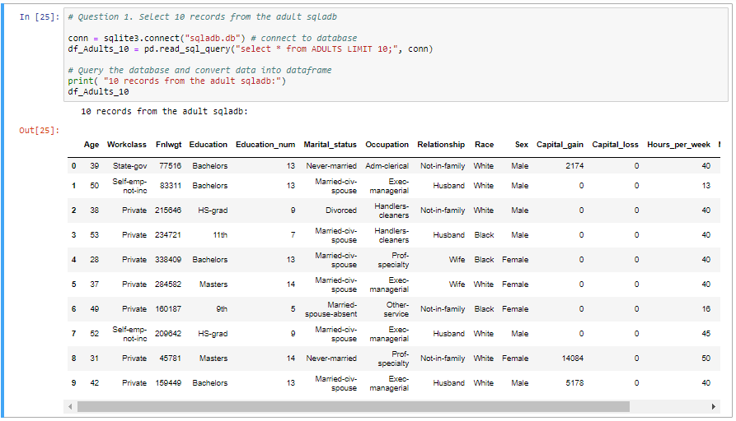

**Question 2:** Show me the average hours per week of all men who are working in private sector

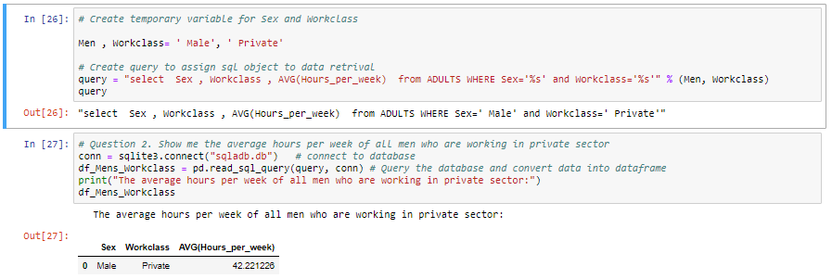

**Question 3:** Show me the frequency table for education, occupation and relationship, separately

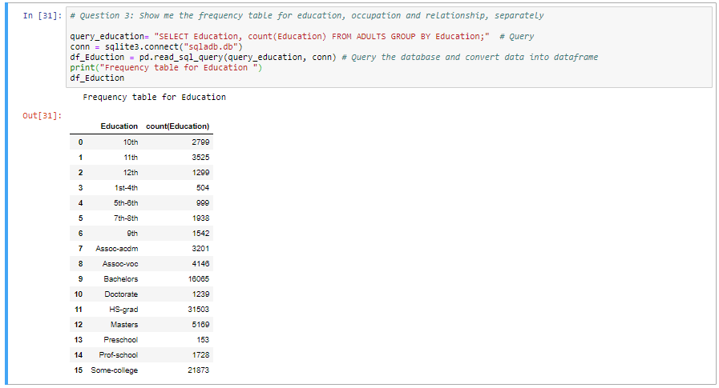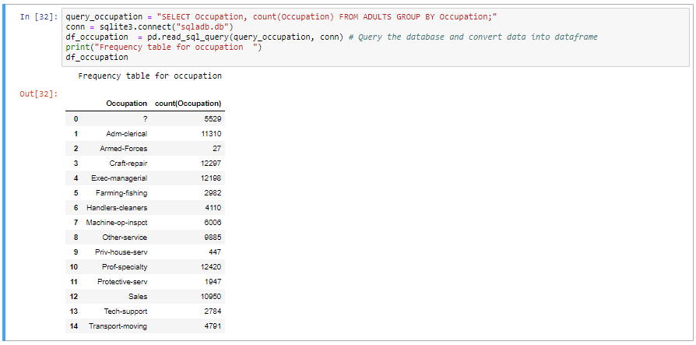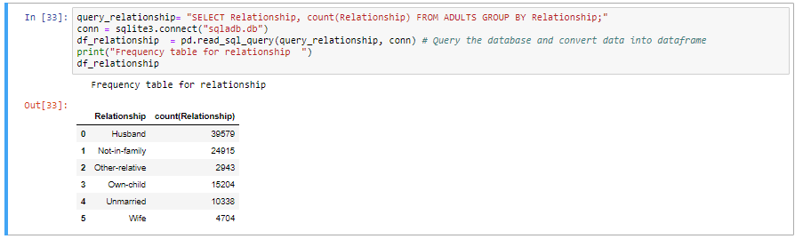

**Question 4:** Are there any people who are married, working in private sector and having a masters

degree

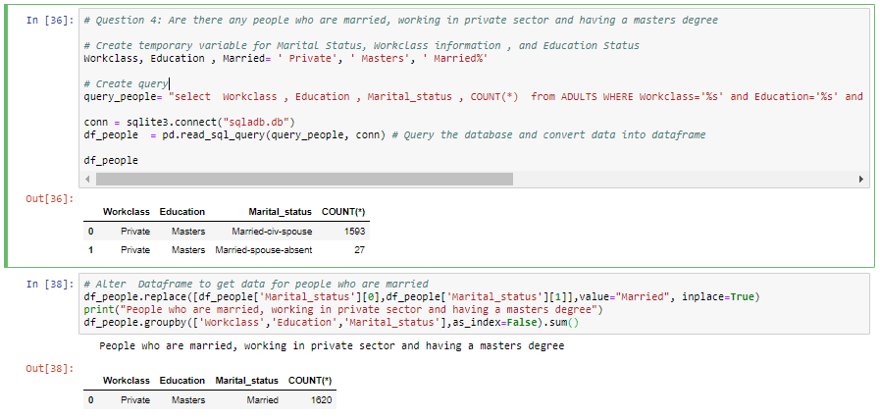

**Question 5:** What is the average, minimum and maximum age group for people working in  
different sectors?

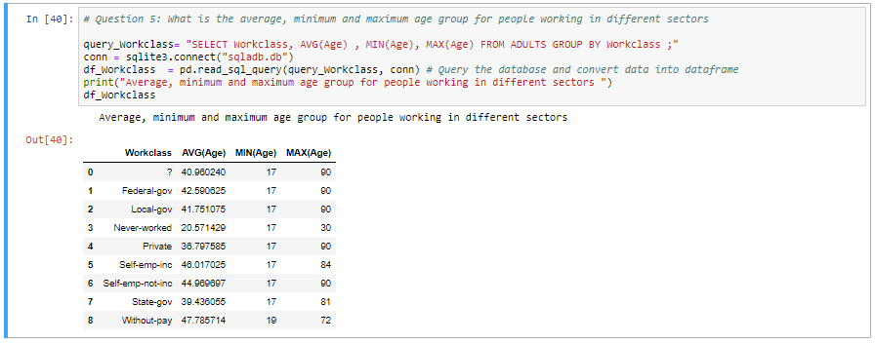

**Question 6:** Calculate age distribution by country

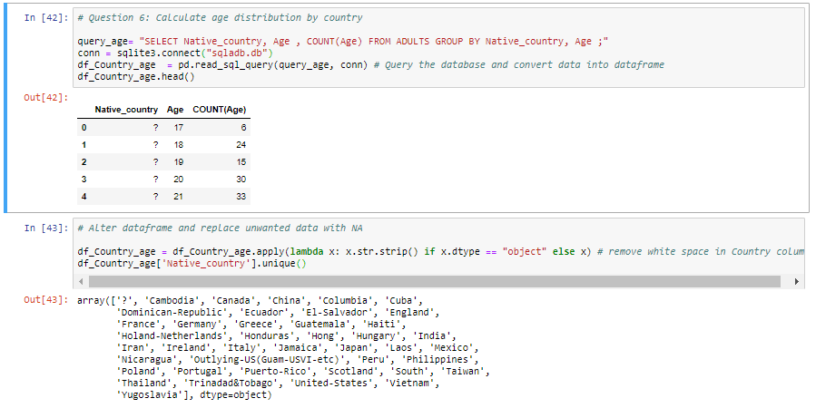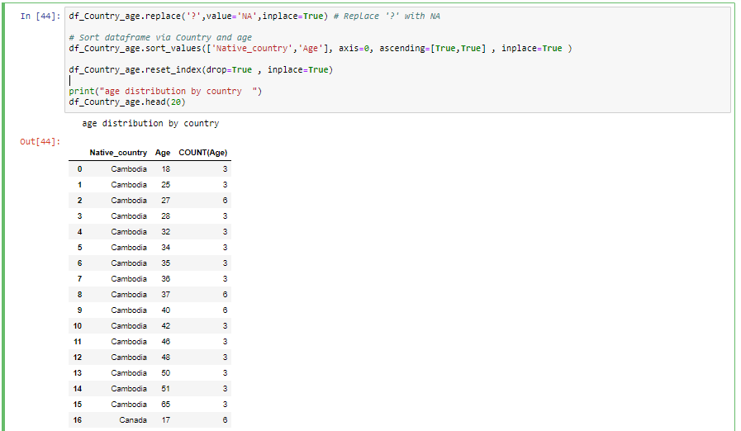

**Question 7:** Compute a new column as 'Net-Capital-Gain' from the two columns 'capital-gain' and  
'capital-loss'



